Scarecrow Activities

Class Scarecrow
Some old clothes, newspaper, and paper grocery sack will work just fine for a classroom scarecrow. Stuff newspaper in the sack and gather the bottom with a rubber band to make a head. Add a face. Let the children wad up newspaper and stuff the clothes. Sit it up in a chair and prop up the head with a dowel rod. Have the children bring in gloves, a hat, boots, etc. from home to complete the scarecrow. Write stories about the scarecrow. What would you do if you were a scarecrow?
Scarecrow Picture Talk
Download a picture of a scarecrow from the internet or use one of the ones on following pages.
- Discuss what a scarecrow does.
- How many details can children notice about the scarecrow?
- Draw lines to label their descriptions.

Draw Your Own
There is a page with a box and a caption. Students can draw their own scarecrows and then tell a story to the class about the scarecrow.

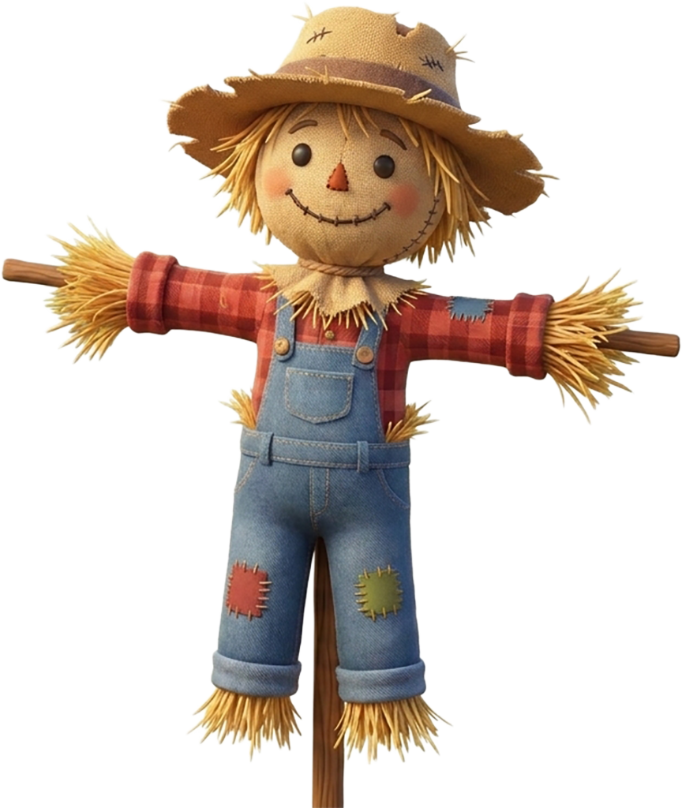

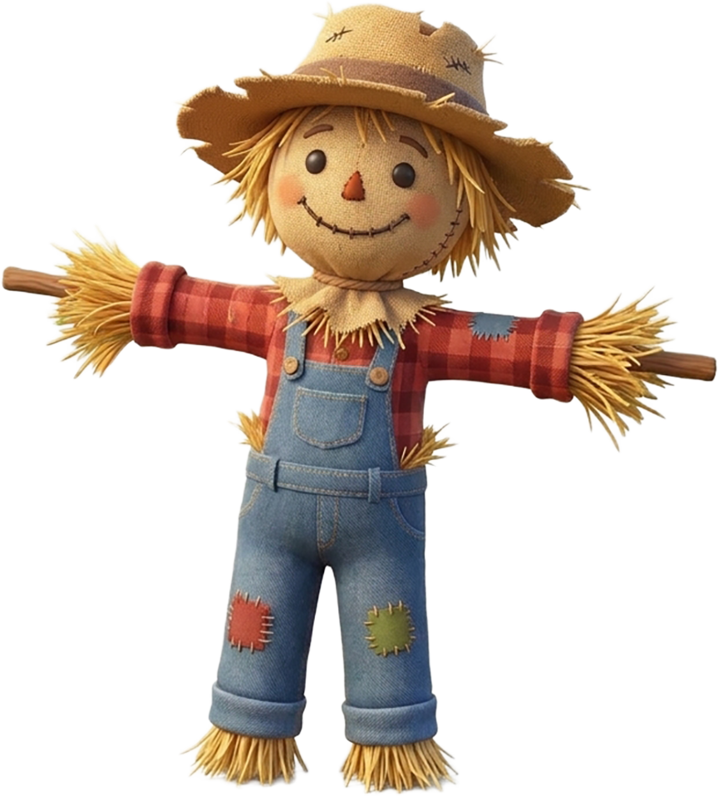

This is my scarecrow friend.
His name is _________________________

