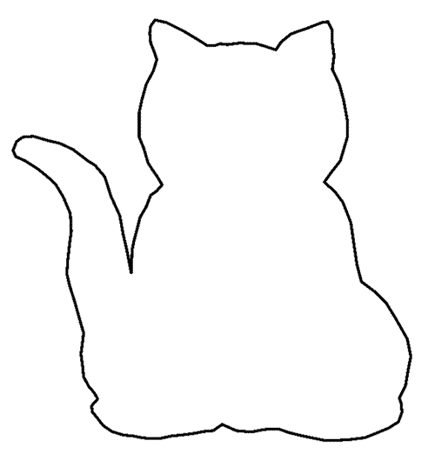
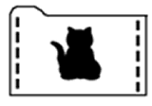
Directions: Take a file folder and cut the cat pattern out of one side. Staple the ends of the folder together to make a pocket. Insert 7” x 10” sheets of construction paper in the pocket and remove one at a time as you tell the story.
This cat pattern can also be used to make cats from felt for the flannel board.
(Order the paper black, green, blue, yellow, red, black.)

