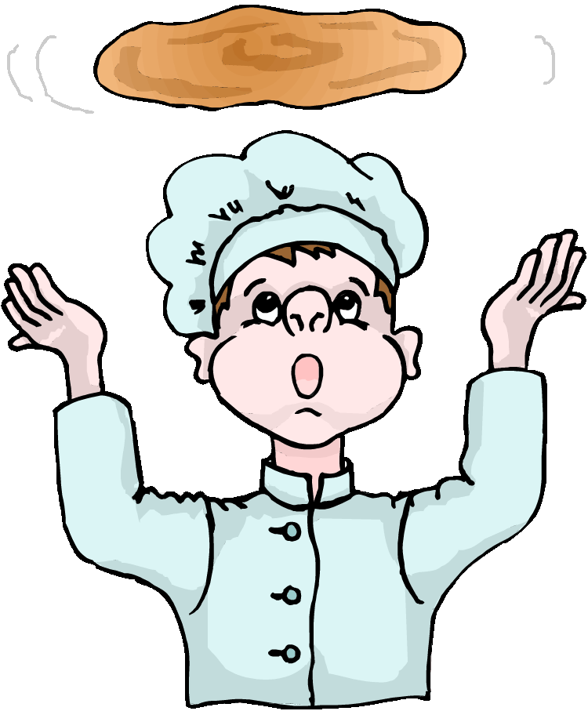

Fraction Pizza

By Dr. Jean
Lyrics by Dr. Holly

I’ve got a whole pizza in my hands.

I’ve got a whole pizza in my hands.

I’ve got a whole pizza in my hands.

And now I’ll eat some up.
.
1/2

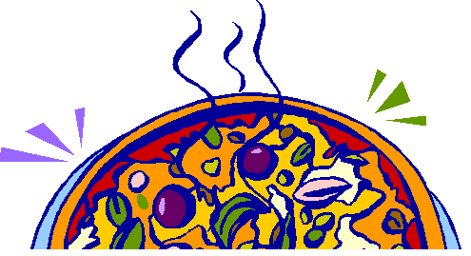

I’ve got half a pizza in my hands.

I’ve got half a pizza in my hands.

I’ve got half a pizza in my hands.

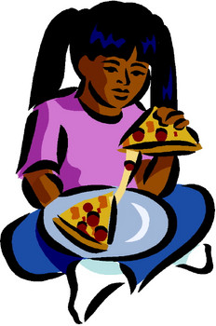

And now I’ll eat some up.

1/4

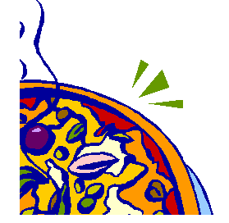

I’ve got one fourth of a pizza in my hands.

I’ve got one fourth of a pizza in my hands.

I’ve got one fourth of a pizza in my hands.

And now I’ll eat some up.

1/8


I’ve got one eighth of a pizza in my hands.

I’ve got one eighth of a pizza in my hands.

I’ve got one eighth of a pizza in my hands.

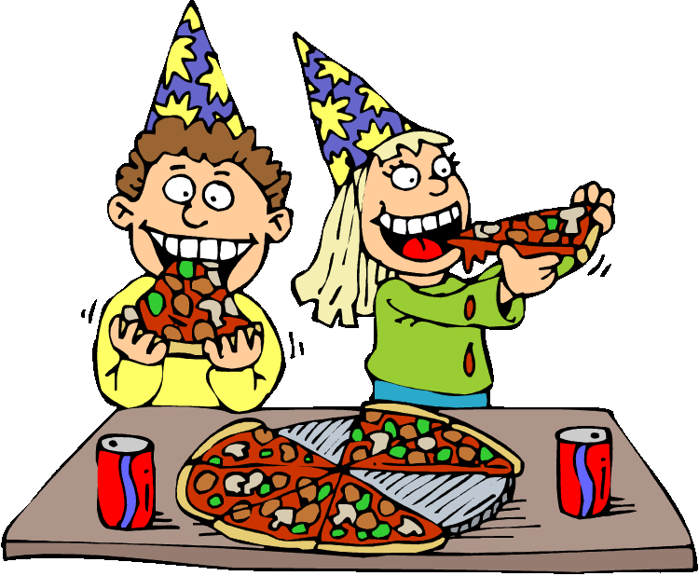

And now I’ll eat it up.

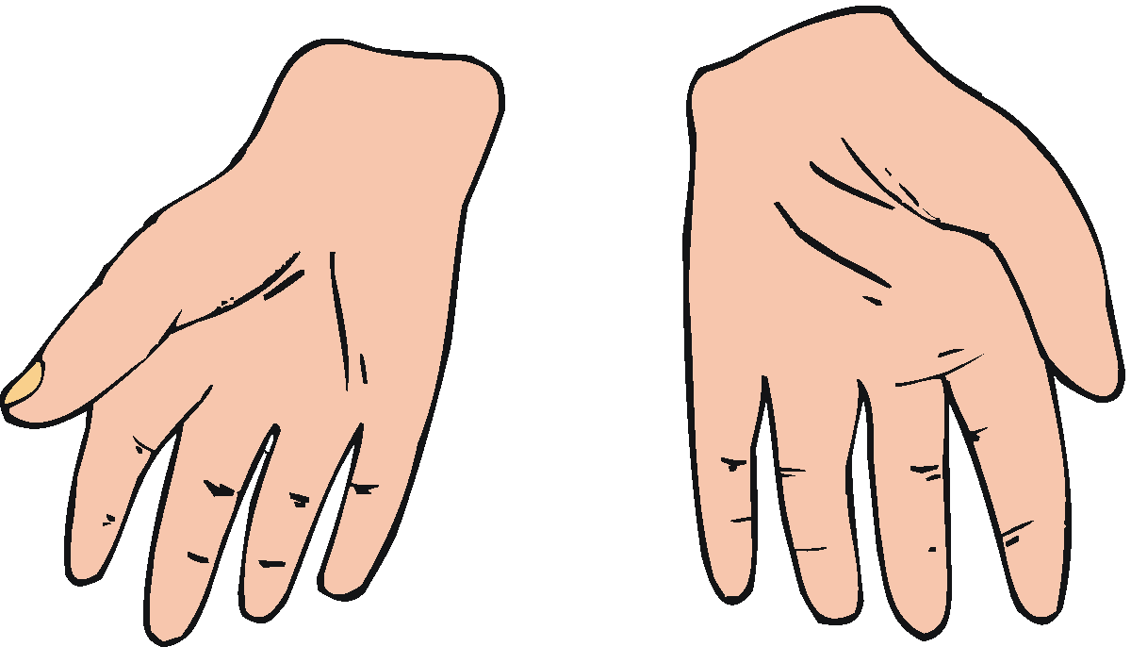

I’ve got no pizza in my hands.

I’ve got no pizza in my hands.

I’ve got no pizza in my hands.

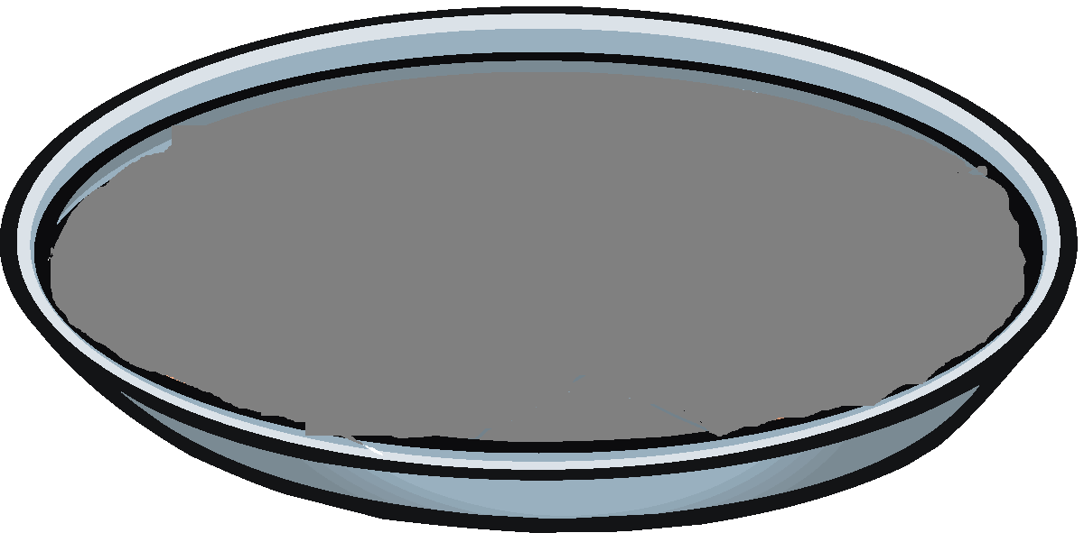

It’s just an empty pan.

