Number Words

Zero 0
One 1 ∗
Two 2 ∗∗
Three 3 ∗∗∗
Four 4 ∗∗∗∗
Five 5 ∗∗∗∗∗
Six 6 ∗∗∗∗∗∗
Seven 7 ∗∗∗∗∗∗∗
Eight 8 ∗∗∗∗∗∗∗∗
Nine 9 ∗∗∗∗∗∗∗∗∗
Ten 10 ∗∗∗∗∗∗∗∗∗∗

Days of the Week | Months of the Year
 | January
Sunday | February
Monday | March
Tuesday | April
Wednesday | May
Thursday | June
Friday | July
Saturday | August
 | September
 | October
 | November
 | December

Shapes

triangle
rectangle
diamond
oval
circle square

Hundreds Chart

0 | 1 | 2 | 3 | 4 | 5 | 6 | 7 | 8 | 9
10 | 11 | 12 | 13 | 14 | 15 | 16 | 17 | 18 | 19
20 | 21 | 22 | 23 | 24 | 25 | 26 | 27 | 28 | 29
30 | 31 | 32 | 33 | 34 | 35 | 36 | 37 | 38 | 39
40 | 41 | 42 | 43 | 44 | 45 | 46 | 47 | 48 | 49
50 | 51 | 52 | 53 | 54 | 55 | 56 | 57 | 58 | 59
60 | 61 | 62 | 63 | 64 | 65 | 66 | 67 | 68 | 69
70 | 71 | 72 | 73 | 74 | 75 | 76 | 77 | 78 | 79
80 | 81 | 82 | 83 | 84 | 85 | 86 | 87 | 88 | 89
90 | 91 | 92 | 93 | 94 | 95 | 96 | 97 | 98 | 99
100

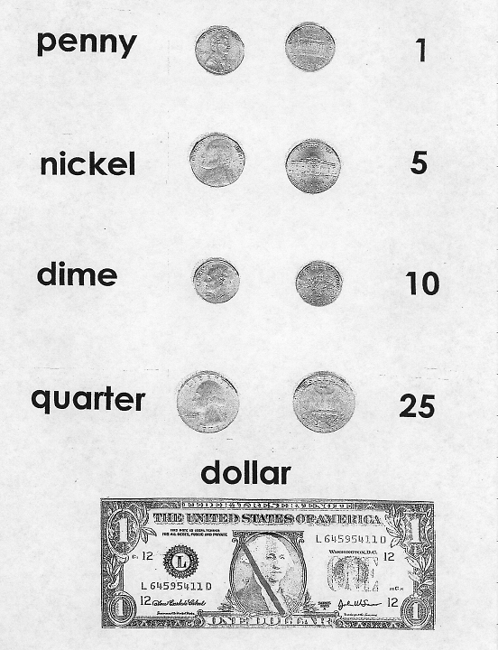

Clock
12
1
2
3
4
5
6
7
.
8
9
10
11
Math Mat

