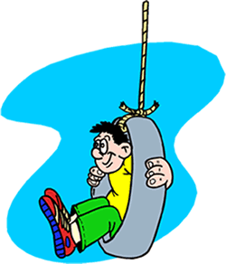

Kids Just Wanna
Have Fun!!

By
Dr. Jean

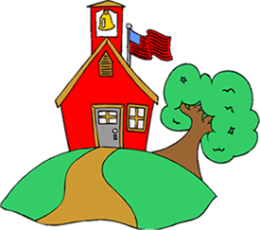

Go to school in the morning light.
All day long we read and do math, think and write.

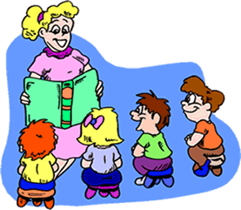

We use our brains, but when the school day is done.

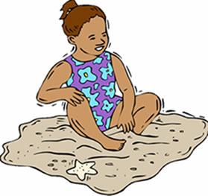

Kids, they wanna have fun.
Oh, kids just wanna have fun.

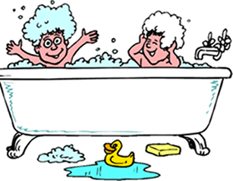

Go home in the afternoon.
With homework and chores and a bath to take, too.

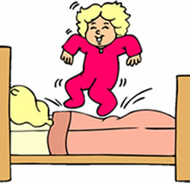

It’s time for bed and the whole day is done.
But, kids, they wanna have fun.
Oh, kids, just wanna have…

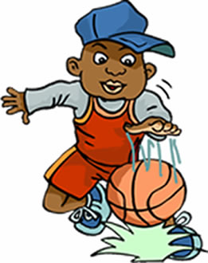

It’s all they really want
When the school day is done.
They’ve worked hard,
And the thinking is done.

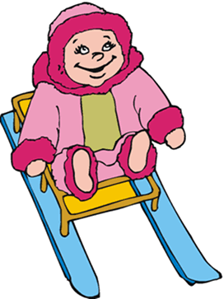

Oh, kids they wanna have fun.
Oh, kids just wanna have fun.
Kids they wanna, wanna have fun.
Kids wanna have….

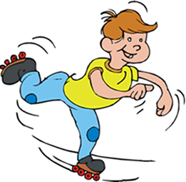

Play outside and ride on our bikes.
Go roller skating and then maybe go on a hike.

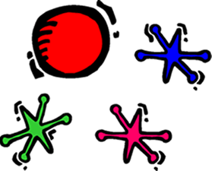

Play games with friends that we like.
Kids, they wanna,have fun,
Oh, kids just wanna have……

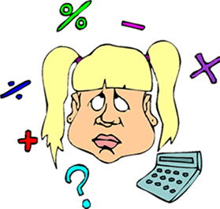

It’s all they really want
When the school day is done.
They’ve worked hard,
And the thinking is done.

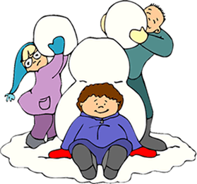

Oh, kids they wanna have fun.
Oh, kids just wanna have fun.
Kids they wanna, wanna have fun.
Kids wanna have fun….
Chorus….

