Weather Song

From the
All Day Long CD

By
Dr. Jean
Clipart by clipart.com

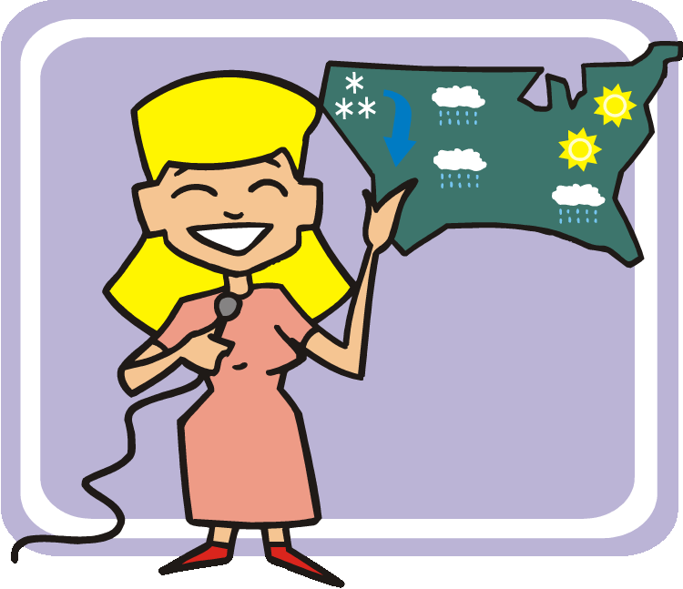

What will the weather,
weather, weather,
What will the weather be today?

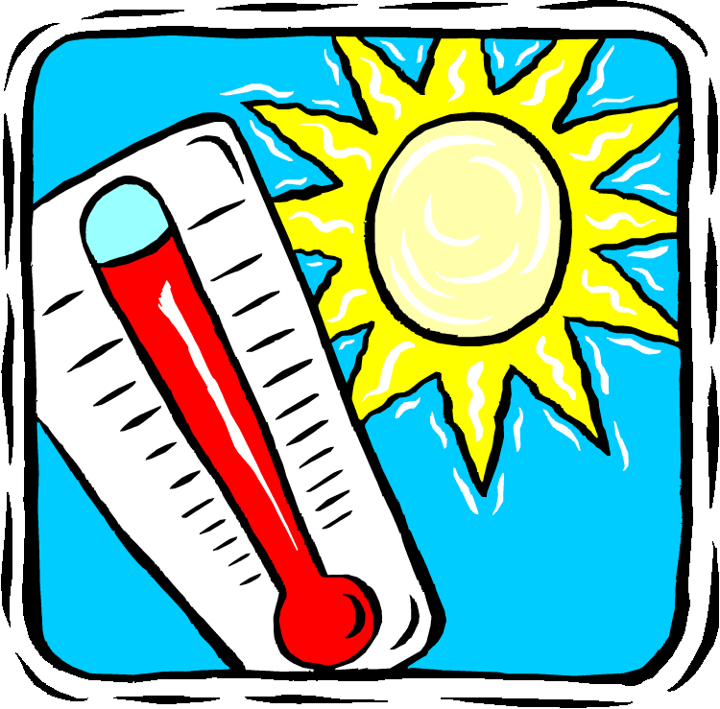

Is it sunny, sunny, sunny?
S-U-N-N-Y today.



Is it cloudy, cloudy, cloudy?
C-L-O-U-D-Y today.

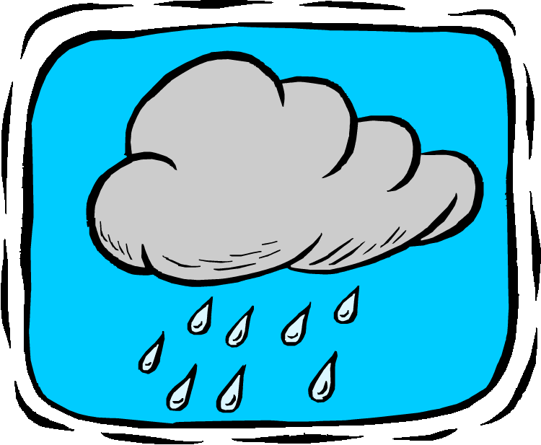

Is it rainy, rainy, rainy?
R-A-I-N-Y today.

Is it foggy, foggy, foggy?
F-O-G-G-Y today.

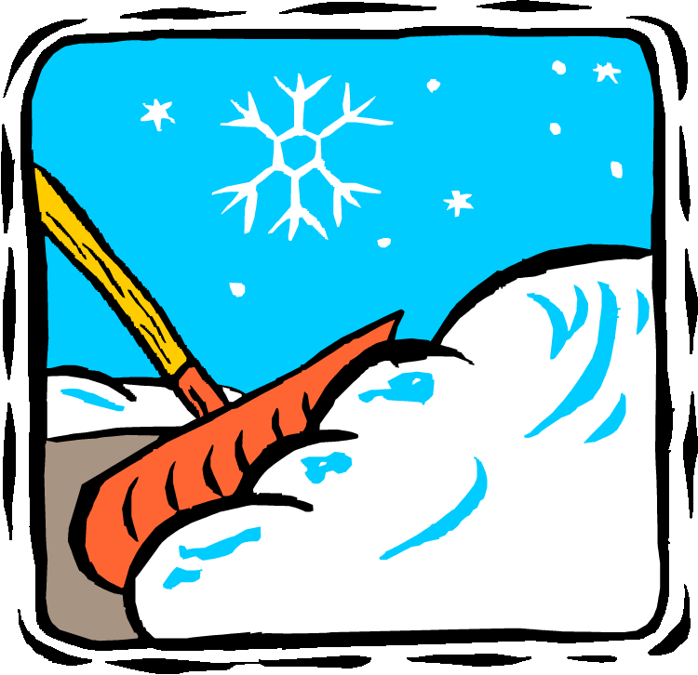

Is it snowy, snowy, snowy?
S-N-O-W-Y today.

