Continents

From the
Sing to Learn CD
by
Dr. Jean
We’ve got the whole globe in our hands.
We’ve got the whole globe in our hands.
We’ve got the whole globe in our hands.

We’ve got the whole globe in our hands.

We’ve got North and South
America in our hands.

We’ve got Europe, Asia, Africa in our hands.

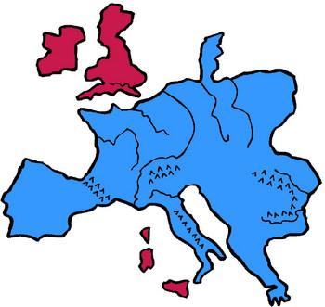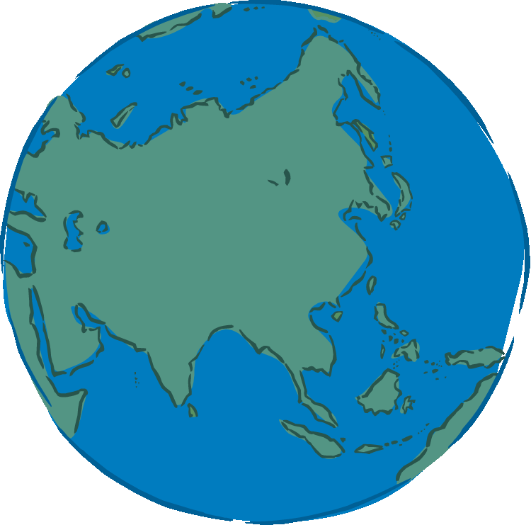

We’ve got Australia and
Antarctica in our hands.

We’ve got the whole globe
in our hands.

We’ve got the whole globe in our hands.

