
Butterfly Bites


You will need:

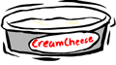
Celery
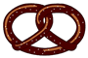
Cream Cheese
Pretzel Twists


Directions:

- Wash your hands
- Clean the celery and cut it into 3” pieces
- Spread the cream cheese on the celery

- Insert 2 pretzels in the cream cheese to make wings
- “Fly” it into your mouth

Hint!

Make a caterpillar by inserting grapes and berries on a toothpick.
