Counting Cadence

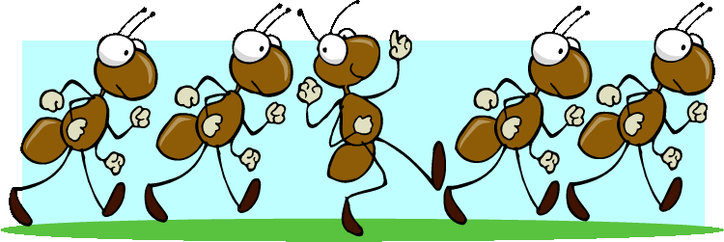

Based on the Counting Cadence song from
the Dr. Jean Feldman Kiss Your Brain CD

Your left, your left, your left, right, left.
Your left, your left, your left, right, left.
We’re the best; we’re number one.
Now let’s have some counting fun.

1 2 3 4 5 6 7 8
9 10 11 12

We are smart, we’re really cool. Come on in. Let’s count by 2’s.

2 4 6 8 10 12 14 16

18 20 22 24

We are rocking you can see.
All together count by 3’s.

3 6 9 12 15 18 21 24

27 30 33 36

We got the beat, and we know more. Everybody count by 4’s.

4 8 12 16 20 24 28 32

36 40 44 48

We can count and we’re alive.
Now let’s try and count by 5’s.

5 10 15 20 25 30 35 40

45 50 55 60

Skip counting is a kick. You can do it.
Count by 6.

6 12 18 24 30 36 42 48

54 60 66 72

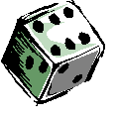

We’re on a roll. Our brains are revving. Everybody count by 7.

7 14 21 28 35 42 49 56

63 70 77 84

We’re fantastic, doing great.
Come on now and count by 8.

8 16 24 32 40 48 56 64

72 80 88 96

Looking good and counting fine.
Now it’s time to count by 9.

9 18 27 36 45 54 63 72

81 90 99 108

Skip count, skip count once again.
One more time and count by 10.

10 20 30 40 50 60 70 80

90 100 110 120

We are super, yes we are, look out _________ becomes a star.

