Applesauce Surprise

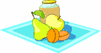
You will need:

Applesauce
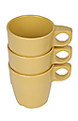

Cinnamon candies

Cups
Spoons

Directions:

- Wash your hands.
- Put applesauce in the cup.


- Count out 8 candies and put them in the cup.
- Stir, stir, stir until the applesauce
turns pink and the candy dissolves.
- It’s a cinnamon surprise!

Hint! Stir in miniature M&M’s, and it will look like a rainbow as they
dissolve in the applesauce.

