Turkey Talk

This is a good story to draw on the board or use with an overhead projector.

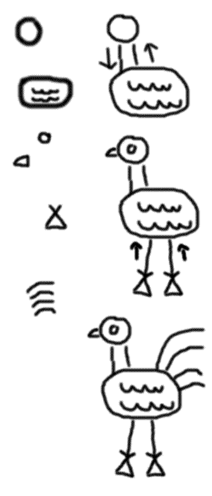

Once there was a little old woman who lived with her
husband far out in the woods in a round house.

Every day she would walk down to the lake to watch
the fish swim. Then she would walk back home.

Her husband was very nosey. He'd look out the
window and watch her. Sometimes he'd even stick
his nose out the door.

People in the city heard about the beautiful lake.
They came out and pitched tents near the lake.
They, too, liked to walk to the lake and watch the fish
swim. Sometimes they would wave to the old
woman.

One fine fall day they heard a strange noise down at
the lake. Birds were flying out of the water and
making a big splash.

The old woman, and her husband, and the people in
the tents all went running to the lake. Do you know
what they saw? You're a TURKEY if you can't see it.

From Activities for November 2005
http://drjean.org/

