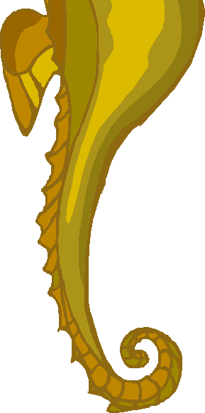

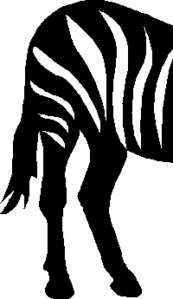
Letter Tales


Song by Dr Jean Feldman

From the “Just for Fun” CD

This is a tale about the letter A.
It makes a special sound.

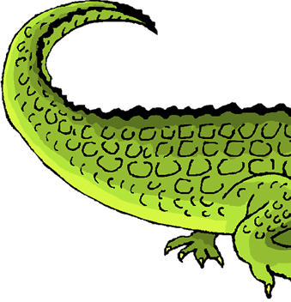
A

Let’s learn another sound.
This is a tale about the letter B.
It makes a special sound.


B

Let’s learn another sound.
This is a tale about the letter C.
It makes a special sound.

C

Let’s learn another sound.
This is a tale about the letter D.
It makes a special sound.


D

Let’s learn another sound.
This is a tale about the letter E.
It makes a special sound.


E

Let’s learn another sound.
This is a tale about the letter F.
It makes a special sound.

F
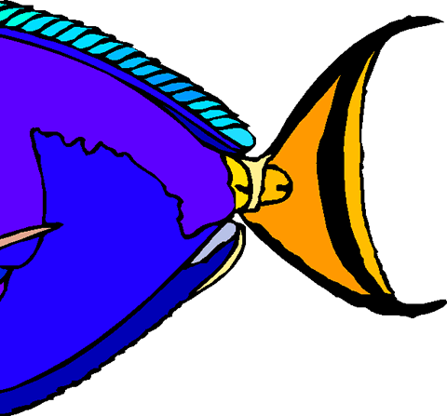

Let’s learn another sound.
This is a tale about the letter G.
It makes a special sound.

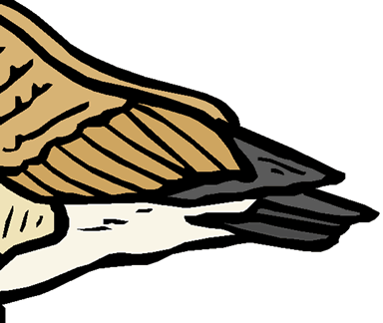
G

Let’s learn another sound.
This is a tale about the letter H.
It makes a special sound.


H

Let’s learn another sound.
This is a tale about the letter I.
It makes a special sound.
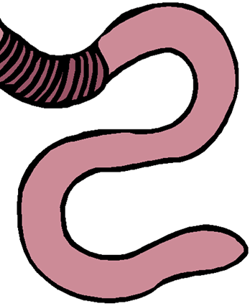

I

Let’s learn another sound.

This is a tale about the letter J.
It makes a special sound.

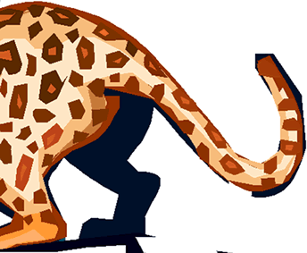
J

Let’s learn another sound.

This is a tale about the letter K.
It makes a special sound.

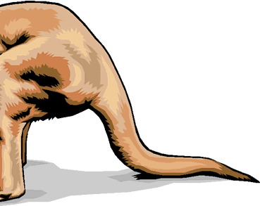
K

Let’s learn another sound.
This is a tale about the letter L.
It makes a special sound.


L

Let’s learn another sound.
This is a tale about the letter M.
It makes a special sound.

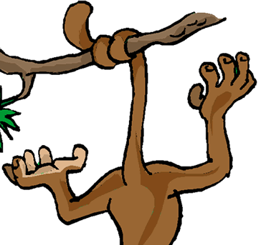

M

Let’s learn another sound.
This is a tale about the letter N.
It makes a special sound.


N

Let’s learn another sound.
This is a tale about the letter O.
It makes a special sound.
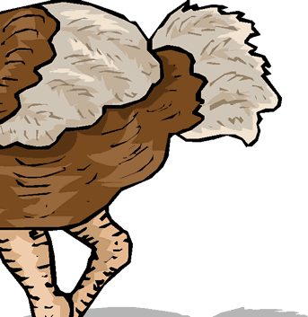

O

Let’s learn another sound.

This is a tale about the letter P.
It makes a special sound.


P

Let’s learn another sound.
This is a tale about the letter Q.
It makes a special sound.

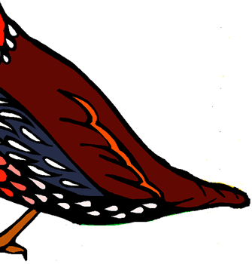
Q

Let’s learn another sound.
This is a tale about the letter R.
It makes a special sound.

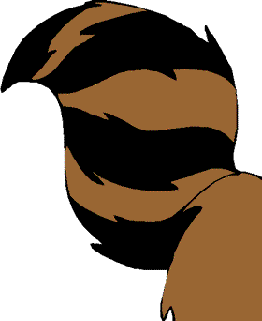
R

Let’s learn another sound.
This is a tale about the letter S.
It makes a special sound.

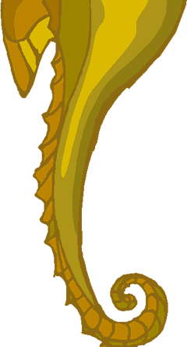
S

Let’s learn another sound.
This is a tale about the letter T.
It makes a special sound.


T

Let’s learn another sound.
This is a tale about the letter U.
It makes a special sound.


U

Let’s learn another sound.
This is a tale about the letter V.
It makes a special sound.


V

Let’s learn another sound.
This is a tale about the letter W.
It makes a special sound.


W

Let’s learn another sound.
This is a tale about the letter X.
It makes a special sound.


X

Let’s learn another sound.

This is a tale about the letter Y.
It makes a special sound.

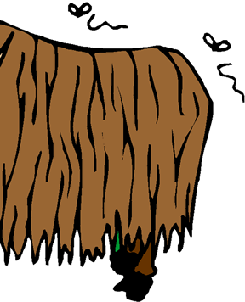
Y

Let’s learn another sound.

This is a tale about the letter Z.
It makes a special sound.

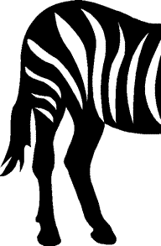
Z

Now you know all your sounds!

