Peanut Butter
By
Dr. Jean

(Tune: Alouette)
Keep on Singing and Dancing CD
Peanut Butter

By
Dr. Jean
(Tune: Alouette)
Keep on Singing and Dancing CD

Peanut butter, we like peanut butter.
Peanut butter, that's what we like best.

Peanut butter, we like peanut butter.
Peanut butter, that's what we like best.

Do you like it on your head?
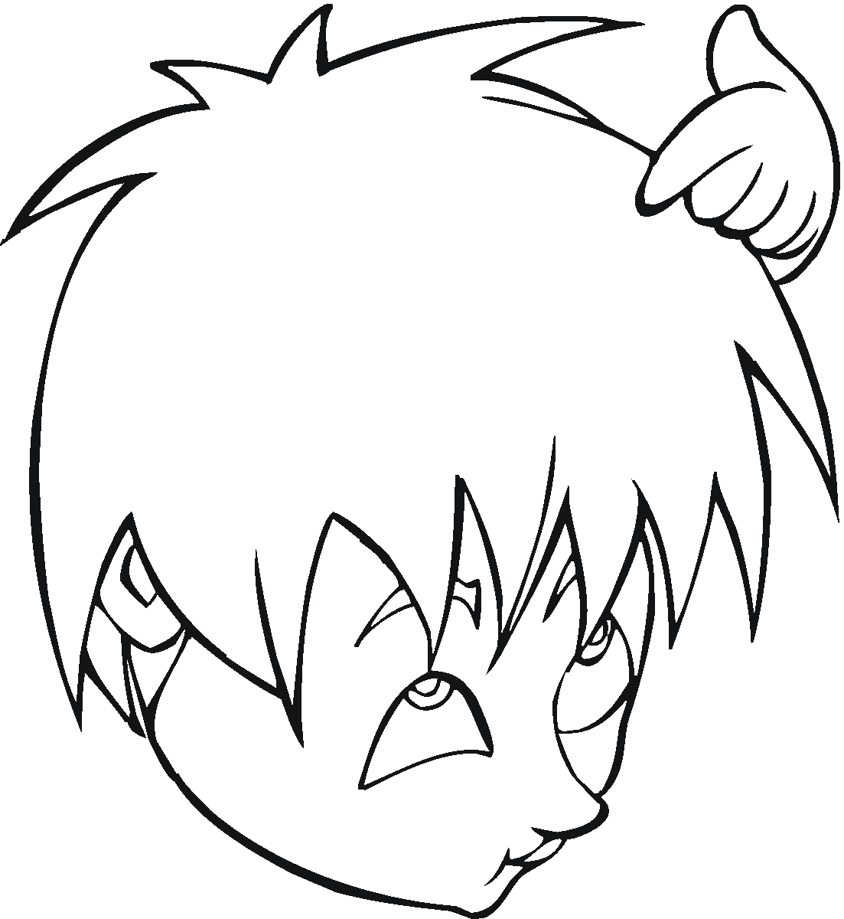

Yes, we like it on our head.
On your head?
On our head. Ohhhhhh.
Do you like it on your head?

Yes, we like it on our head.
On your head?
On our head. Ohhhhhh.

Peanut butter, we like peanut butter.
Peanut butter, that's what we like best.

Peanut butter, we like peanut butter.
Peanut butter, that's what we like best.

Do you like it on your shirt?
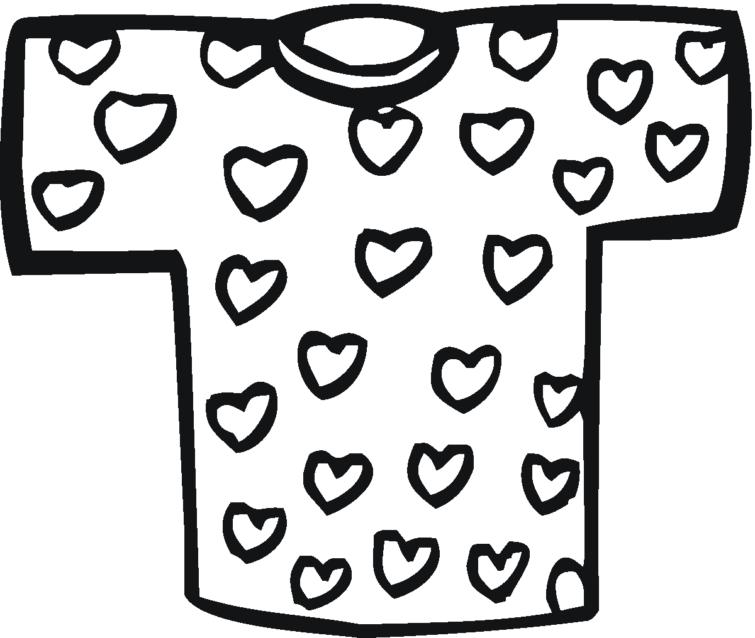
Yes, we like it on our shirt.
On your shirt?
On our shirt.
Ohhhhhh.
Do you like it on your shirt?
Yes, we like it on our shirt.
On your shirt?
On our shirt.
Ohhhhhh.

Peanut butter, we like peanut butter.
Peanut butter, that's what we like best.

Peanut butter, we like peanut butter.
Peanut butter, that's what we like best.

Do you like it on your pants ?
Yes, we like it on our pants.
On your pants?
On our pants. Ohhhhhh.
Do you like it on your pants ?
Yes, we like it on our pants.
On your pants?
On our pants. Ohhhhhh.

Peanut butter, we like peanut butter.
Peanut butter, that's what we like best.

Peanut butter, we like peanut butter.
Peanut butter, that's what we like best.

Do you like it on your socks?
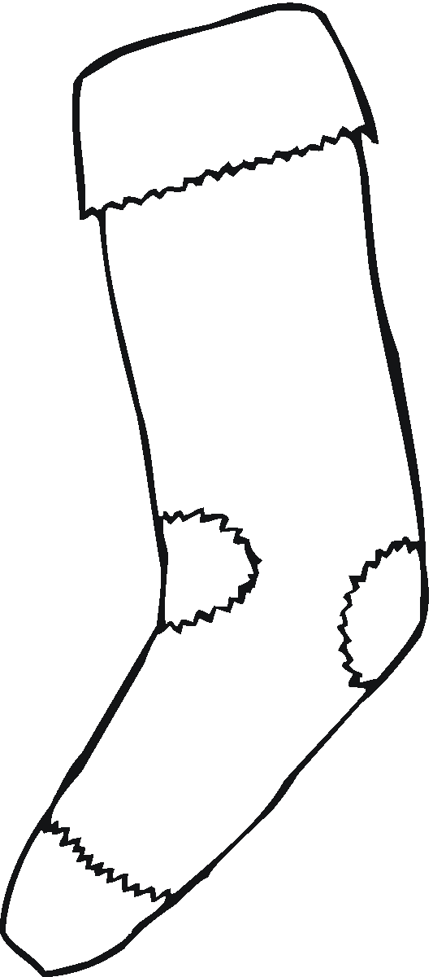
Yes, we like it on our socks.
On your socks?
On our socks. Ohhhhhh.
Do you like it on your socks?
Yes, we like it on our socks.
On your socks?
On our socks. Ohhhhhh.

Peanut butter, we like peanut butter.
Peanut butter, that's what we like best.

Peanut butter, we like peanut butter.
Peanut butter, that's what we like best.

Do you like it on your shoes?
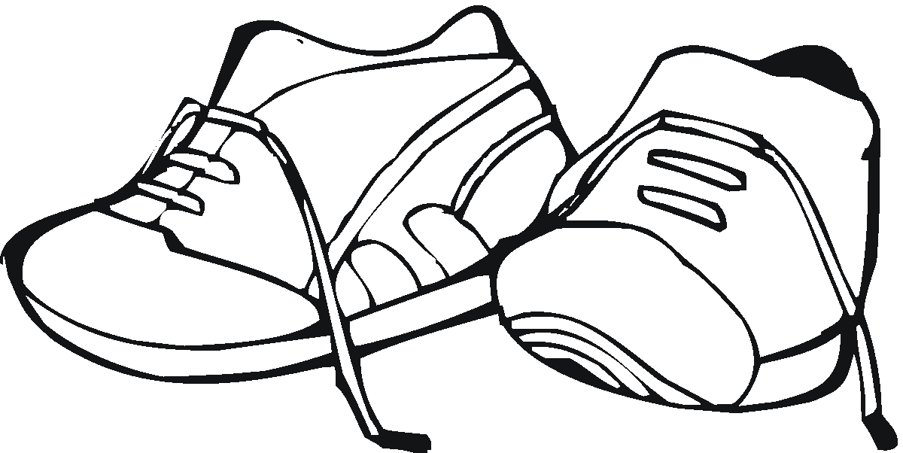

Yes, we like it on our shoes.
On your shoes?
On our shoes.
Ohhhhhh.
Do you like it on your shoes?

Yes, we like it on our shoes.
On your shoes?
On our shoes.
Ohhhhhh.

Peanut butter, we like peanut butter.
Peanut butter, that's what we like best.

Peanut butter, we like peanut butter.
Peanut butter, that's what we like best.

Do you like it on your underwear?
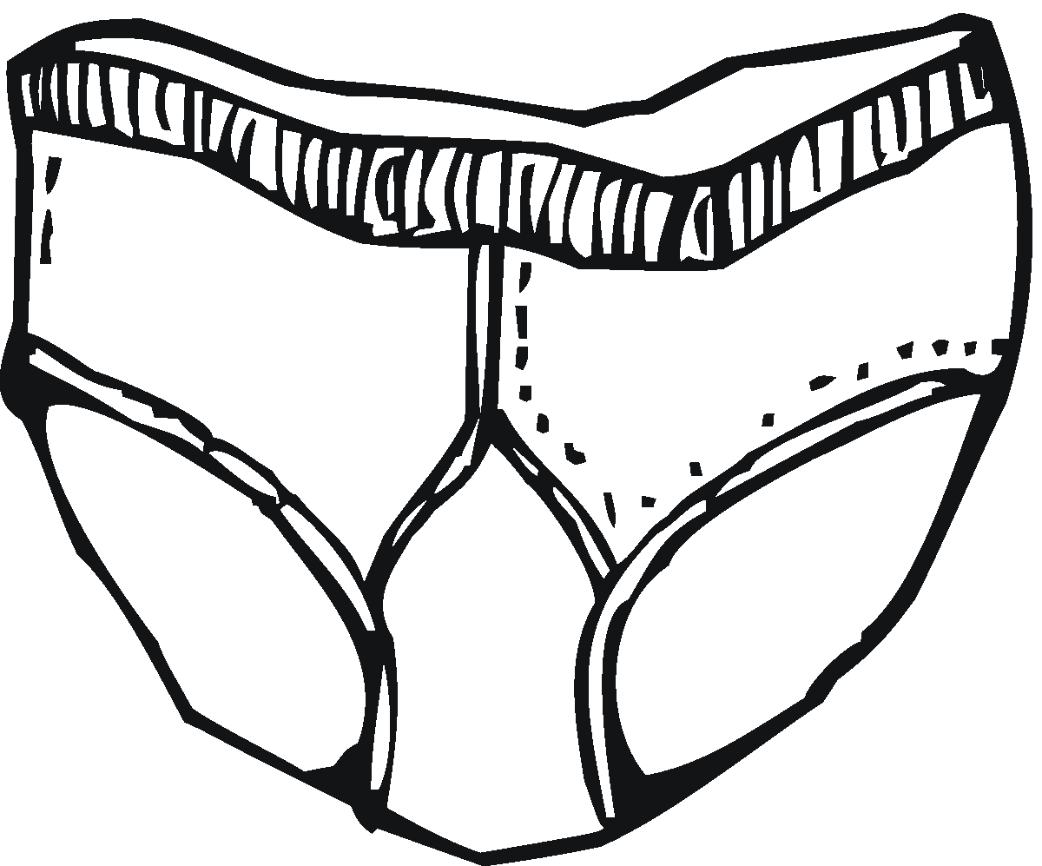

Yes, we like it on our underwear.
On your underwear?
On our underwear. Ohhhhhh.
Do you like it on your underwear?

Yes, we like it on our underwear.
On your underwear?
On our underwear. Ohhhhhh

Peanut butter, we like peanut butter.
Peanut butter, that's what we like best.

Peanut butter, we like peanut butter.
Peanut butter, that's what we like best.

