

The First Twelve Days of School


(Tune: Twelve Days of Christmas)
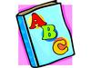


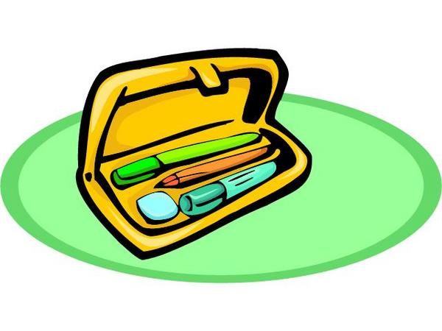






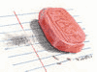

By: Dr. Jean

On the first day of school
My teacher gave to me
A book of the A B C’s.

On the second day of school
My teacher gave to me
Two new pencils . . . .



On the third day of school
My teacher gave to me
Three color crayons . . . .

On the 4th day of school
My teacher gave to me
Four glue sticks . . . .

On the 5th day of school
My teacher gave to me
Five gold stars . . . .

On the 6th day of school
My teacher gave to me
Six pairs of scissors . . . .

On the 7th day of school
My teacher gave to me
Seven school boxes . . . .

On the 8th day of school
My teacher gave to me
Eight spiral notebooks . . . .

On the 9th day of school
My teacher gave to me
Nine wooden rulers . . . .

On the 10th day of school
My teacher gave to me
Ten magic markers . . . .

On the 11th day of school
My teacher gave to me
Eleven pink erasers . . . .

On the 12th day of school
My teacher gave to me
Twelve library books . . . .

