A for apple B for bounce C for cut
/a/ /a/ /a/ /b/ /b/ /b/ /b/ /b/ /c/ /c/ /c/

D for dig E for elbow F for fan
/d/ /d/ /d/ /e/ /e/ /e/ /f/ /f/ /f/ /f/ /f/

G for gallop H for hop I for itch
/g/ /g/ /g/ /h/ /h/ /h/ /i/ /i/ /i/

J for jump K for kick L for love
/j/ /j/ /j/ /j/ /j/ /k/ /k/ /k/ /l/ /l/ /l/

M for munch N for nod O for opera
/m/ /m/ /m/ /n/ /n/ /n/ /n/ /n/ /o/ /o/ /o/

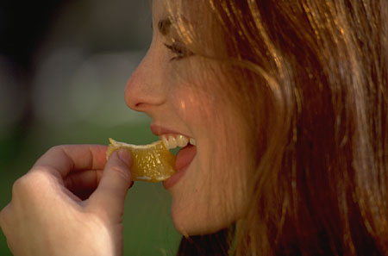

P for push Q for quiet R for run
/p/ /p/ /p/ /kw/ /kw/ /kw/ /r/ /r/ /r/ /r/ /r/

S for sew T for talk U for upside
/s/ /s/ /s/ /t/ /t/ /t/ /u/ /u/ /u/

V for volley W for wiggle X for x-ray
/v/ /v/ /v/ /v/ /v/ /w/ /w/ /w/ /ks/ /ks/ /ks/

Y for yawn Z for zigzag
/y/ /y/ /y/ /z/ /z/ /z/ /z/ /z/

Letter sounds are all you need.
Put them together and you can read!

