Katalina Matalina

By

Dr. Jean Feldman

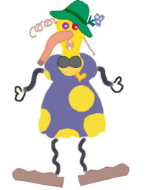

Katalina Matalina

Upsidina Walkadina

Hoca Poca Loca

Was her name!

(Sing the chorus to the tune of "Shortnin' Bread.")

Her head was shaped
Like a baseball bat,
And right on top
Was a funny old hat.
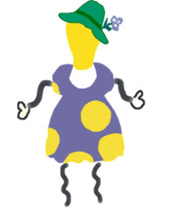

Katalina Matalina

Upsidina Walkadina

Hoca Poca Loca

Was her name!

(Sing the chorus to the tune of "Shortnin' Bread.")

She had two hairs
In her head.
One was alive
And the other was dead.

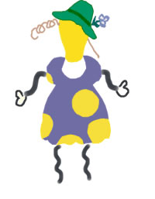

Katalina Matalina

Upsidina Walkadina

Hoca Poca Loca

Was her name!

(Sing the chorus to the tune of "Shortnin' Bread.")

She had two eyes
In her head.
One was purple,
And the other was red.

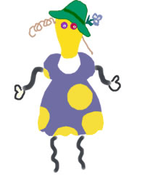

Katalina Matalina

Upsidina Walkadina

Hoca Poca Loca

Was her name!

(Sing the chorus to the tune of "Shortnin' Bread.")

Her nose looked like
A garden hose.
And it hung down
To her toes.

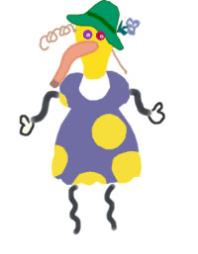

Katalina Matalina

Upsidina Walkadina

Hoca Poca Loca

Was her name!

(Sing the chorus to the tune of "Shortnin' Bread.")

She had two teeth
In her mouth.
One pointed north, and The other pointed south.

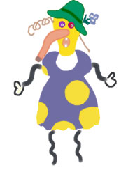

Katalina Matalina

Upsidina Walkadina

Hoca Poca Loca

Was her name!

(Sing the chorus to the tune of "Shortnin' Bread.")

Her neck was as long
As a ten foot pole.
And right in the middle
Was a big, black bow.
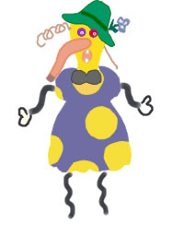

Katalina Matalina

Upsidina Walkadina

Hoca Poca Loca

Was her name!

(Sing the chorus to the tune of "Shortnin' Bread.")

Her hips were as big
As two ships in port.
One headed south, and
The other headed north.

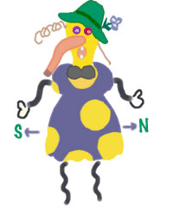

Katalina Matalina

Upsidina Walkadina

Hoca Poca Loca

Was her name!

(Sing the chorus to the tune of "Shortnin' Bread.")

Her feet were as flat
As two bathroom mats.
How did they ever
Get like that?

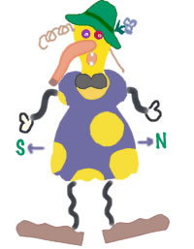

Katalina Matalina

Upsidina Walkadina

Hoca Poca Loca

Was her name!

(Sing the chorus to the tune of "Shortnin' Bread.")

But she had a heart,
So I'm told,
That was made
Of purest gold.

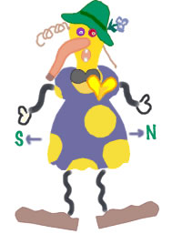

Katalina Matalina

Upsidina Walkadina

Hoca Poca Loca

Was her name!

