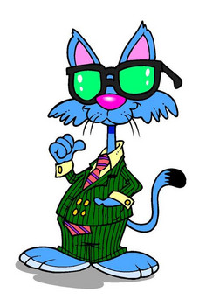
I know that

is a cool cat and a great person.
Kiss Your
Brain!

