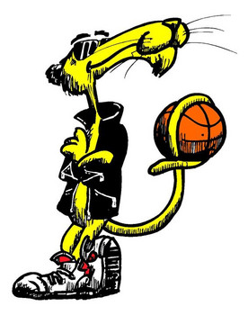

is a really cool cat!
She did a great job today.

