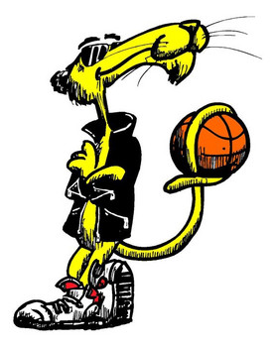

is a really cool cat!
He did a great job today.

