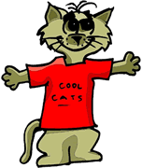
Is a cool cat who did a great job in our class today!

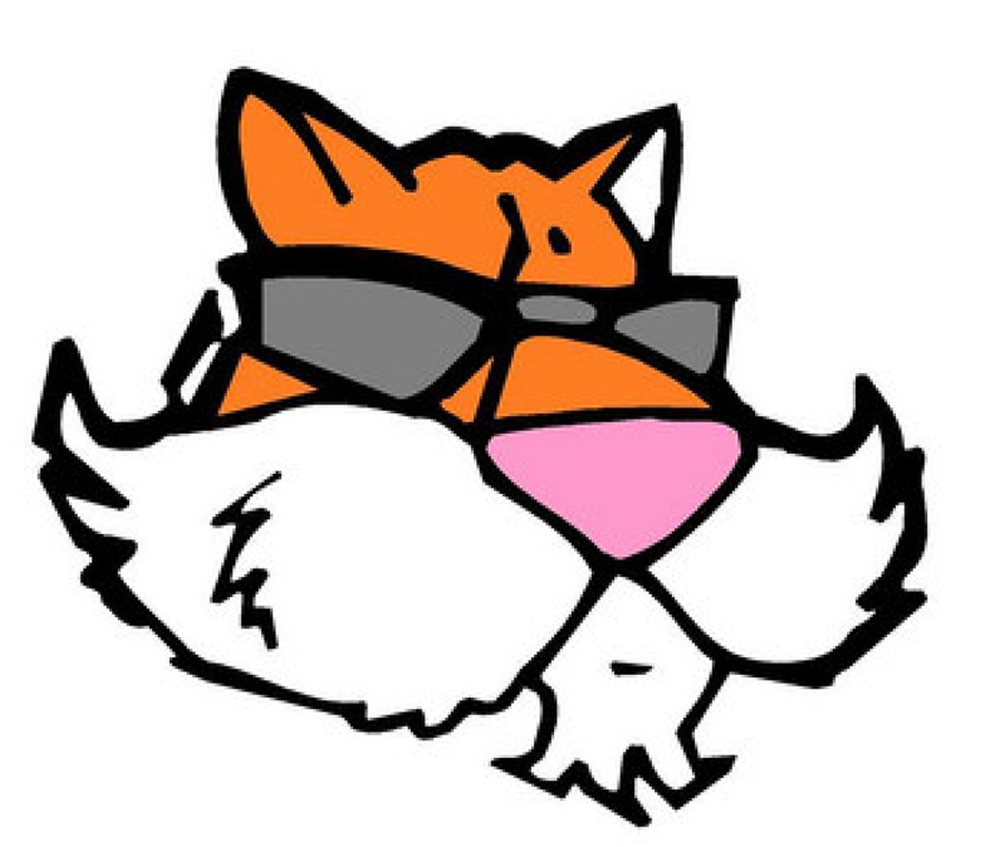
Is one cool cat who did a great job for our class today.

