Found a Penny

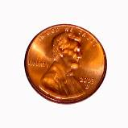

By Dr. Jean

Lyrics by Dr. Holly

Found a penny, found a penny,
Found a penny just now.
It is round and brown and shiny
Found a penny just now.

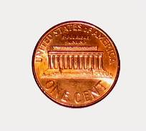

I see Lincoln, I see Lincoln,
Our sixteenth president.
On the back is his Memorial
Penny, penny’s worth one cent.

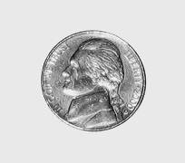

Found a nickel, found a nickel,
Found a nickel just now.
It is round and fat and silver
Found a nickel just now.

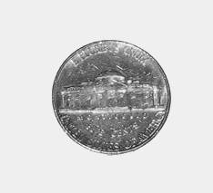

I see Jefferson, I see Jefferson,
Our third president.
On the back is Monticello,
Nickel, nickel’s worth five cents.

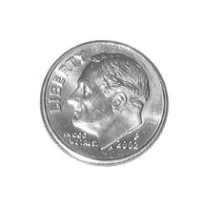

Found a dime, found a dime,
Found a dime just now.
It is thin and small and silver,
Found a dime just now.

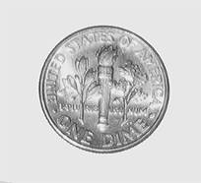

I see Roosevelt, I see Roosevelt,
Our thirty-second president.
On the back is a torch.
One dime is worth ten cents.

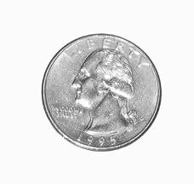

Found a quarter, found a quarter,
Found a quarter just now.
It’ the largest of all the coins,
Found a quarter just now.
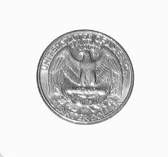

I see Washington, I see Washington,
Our first president.
On the back the bald eagle;
Quarter’s worth twenty-five cents

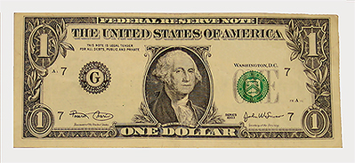

Found a dollar, found a dollar,
Found a dollar just now.
It has a picture of George Washington
And it’s worth one hundred cents.

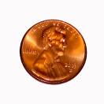

Five pennies equal a nickel.
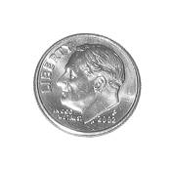

Ten pennies equal a dime.

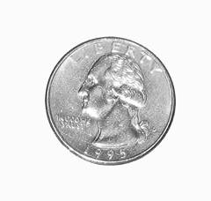
Twenty-five pennies in a quarter,

Two nickels equal a dime.
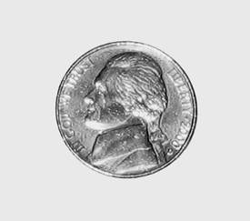
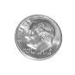
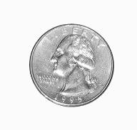
Five nickels in a quarter, or a nickel and two dimes;

Four quarters in a dollar

And a dollar equals ten dimes.

